**Practical Task 1:** Introduction to Microsoft Entra ID Create a basic Microsoft Entra ID setup for an organization to manage identity and access. Requirements:

**1.** **Create a new Microsoft Entra ID tenant.** – Entra ID tenant was created automatically after acquiring subscription for account

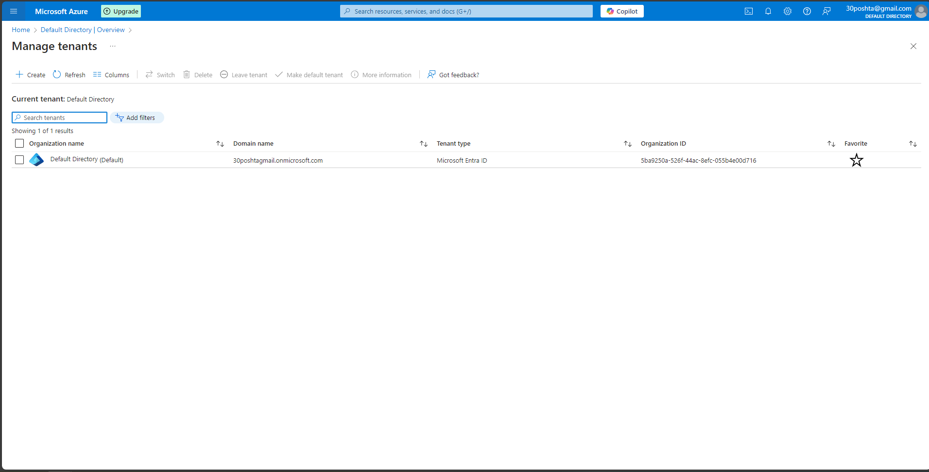

**2.** **Add at least two users to the directory.** – added users to the default directory

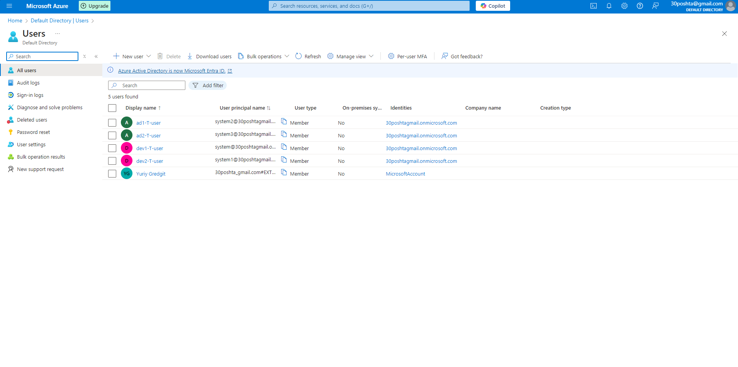

**3. Create two groups named Developers and Admins.** – added users to two respective groups – devs and admins

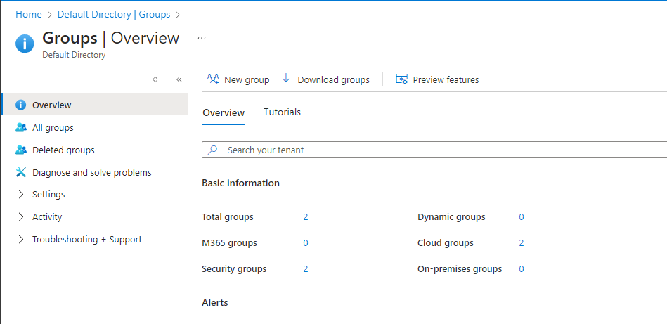

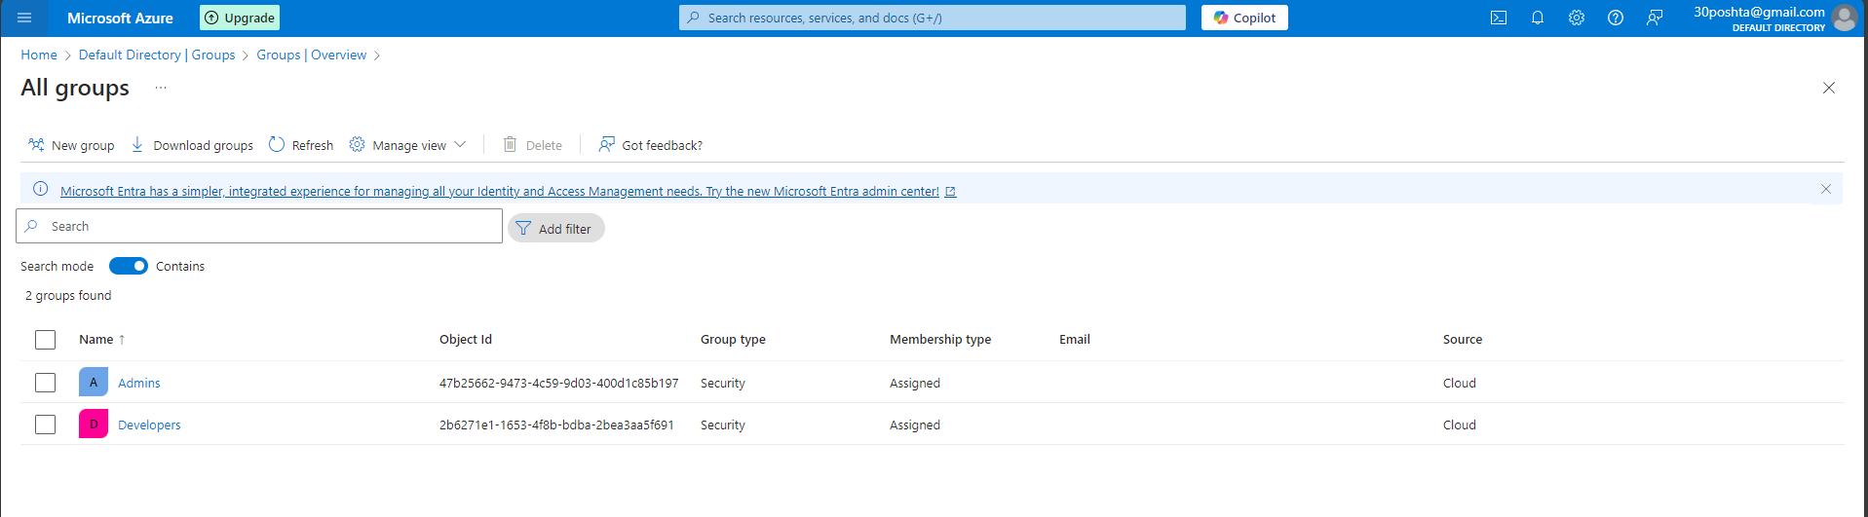

**4. Assign the users to appropriate groups.** – added users to two respective groups – devs and admins

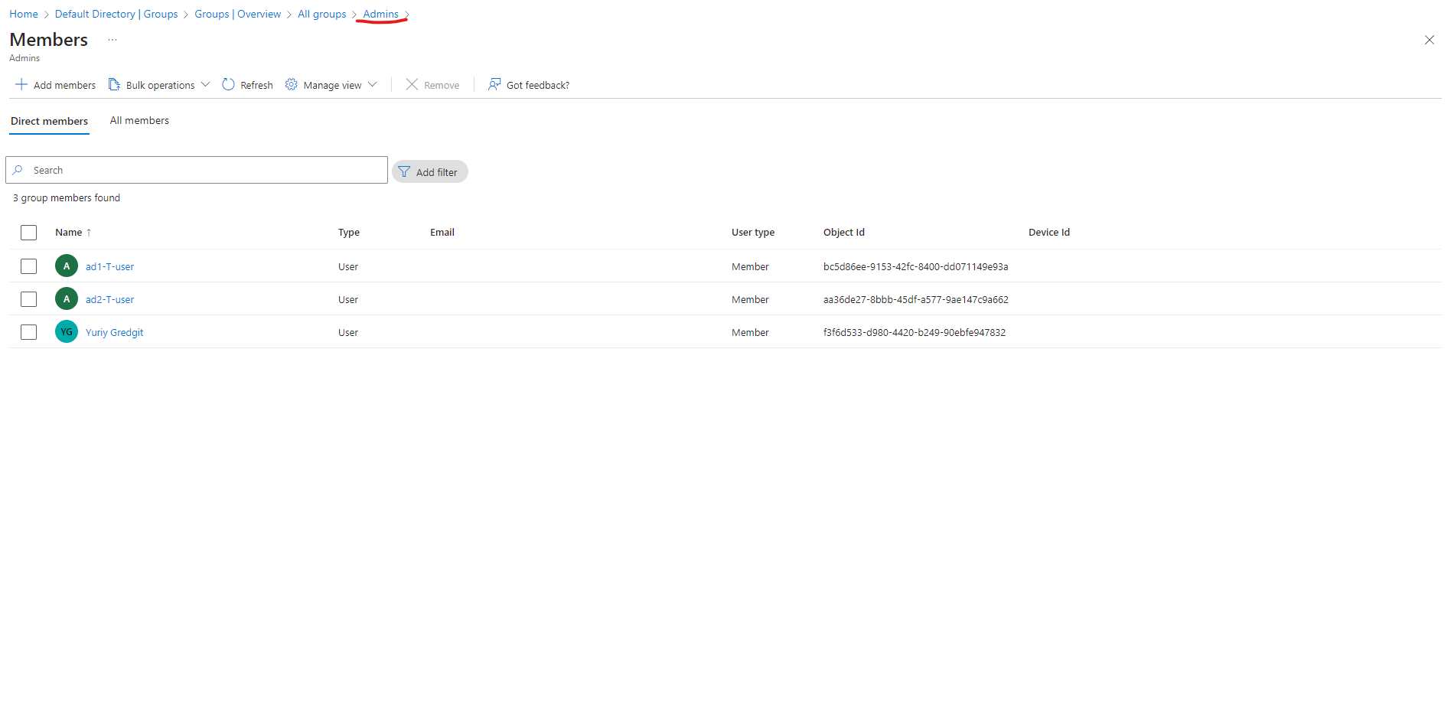

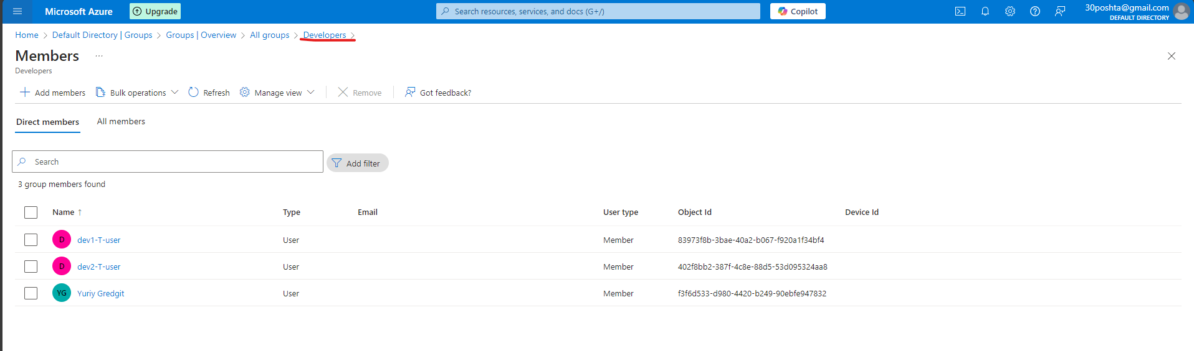

**5. Assign the Global Reader role to the Admins group. –** added reader instead of global reader role because can`t add any entra ID roles to groups without entra p1 license

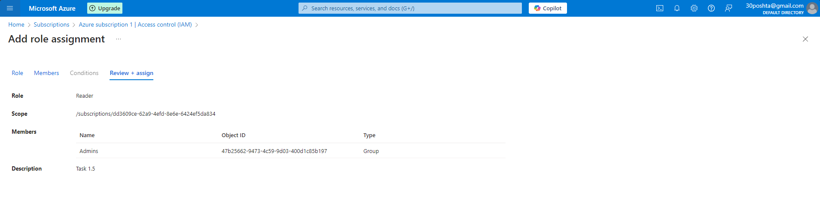

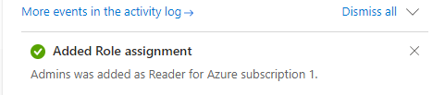

**6. Assign the Application Developer role to the Developers group. -** added contributor instead of app developer role because can`t add custom roles without entra p1 license

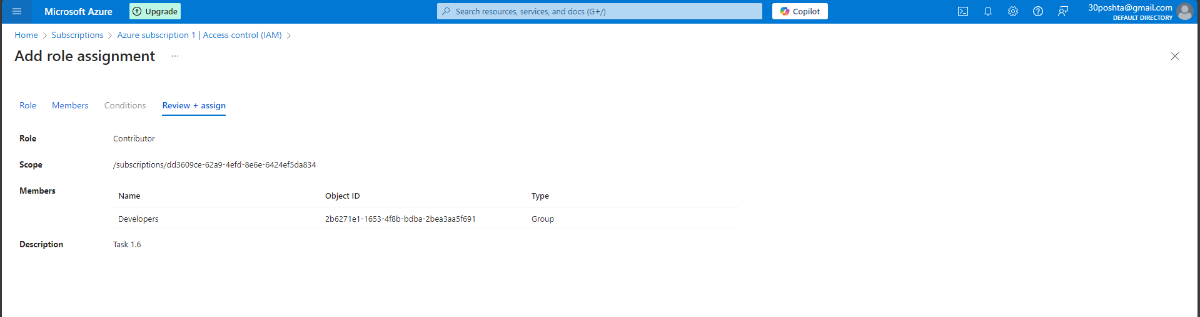 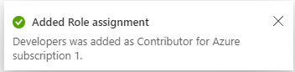

**7. Verify that the role assignments function as expected for both groups.**

**Case 7.1:** According to reader role user which has this role assigned gets “View all resources, but does not allow you to make any changes.” – in order to verify, logged in as one of the admins group users and tried to add role assignment: 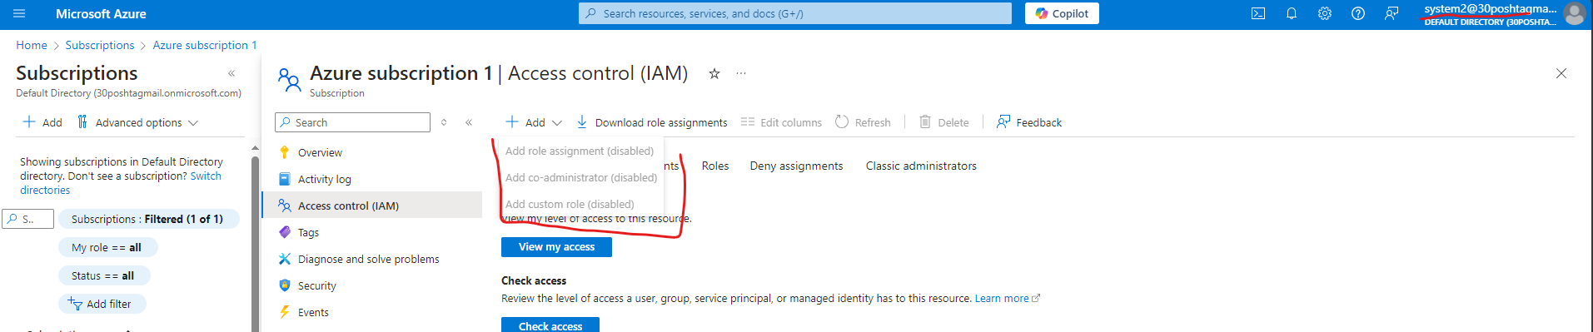

**Case 7.2:** According to contributor role user which has this role assigned gets “full access to manage all resources, but does not allow you to assign roles in Azure RBAC, manage assignments in Azure Blueprints, or share image galleries.” – in order to verify, logged in as one of the developers group users and tried to add role assignment: 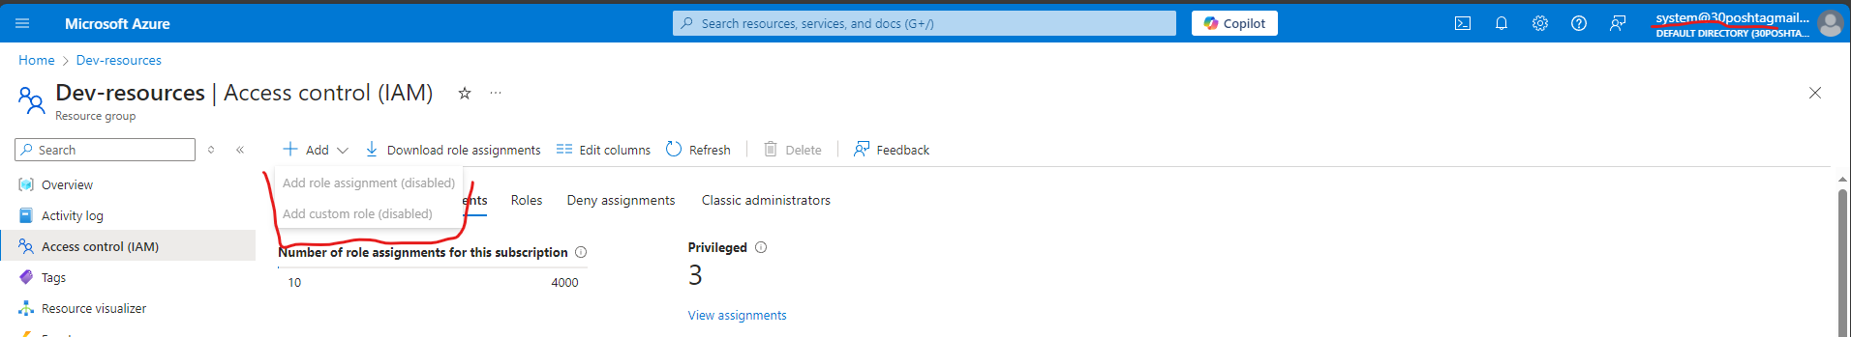

**Practical Task 2:** Enabling Single Sign-On (SSO) and Multi-Factor Authentication (MFA) Configure Single Sign-On (SSO) and Multi-Factor Authentication (MFA) for users in a Microsoft Entra ID directory to enhance identity and access security. Requirements:

**1. Enable Single Sign-On (SSO) for your Microsoft Entra ID tenant. –** SSO wasn`t enabled due to difficulties with configuring it

**2. Enforce Multi-Factor Authentication (MFA) for all users in the directory. –** MFA was enabled and verified by logging in a sone of the dev group users.

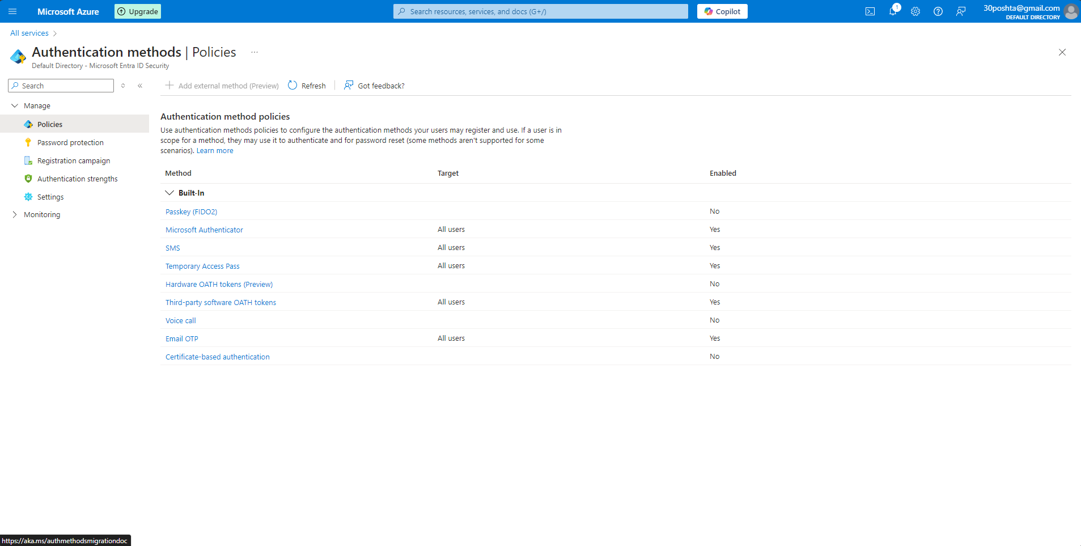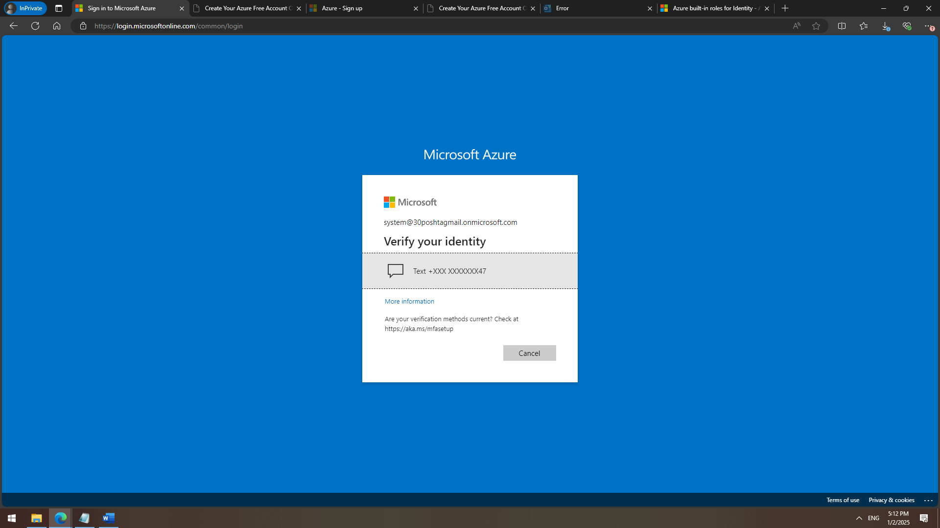

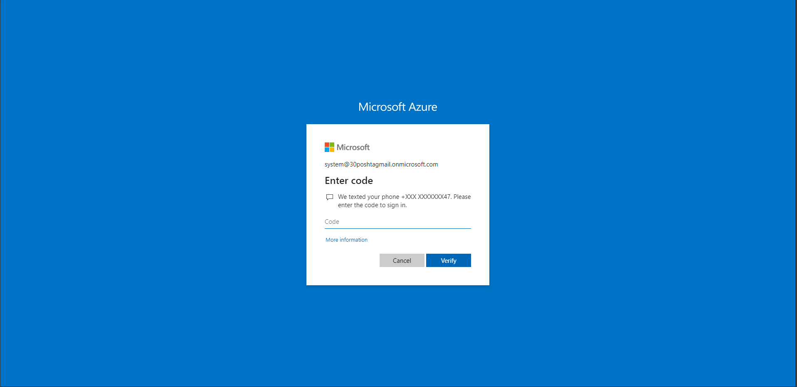

**3. Configure conditional access policies to require MFA for high-risk sign-ins.**

**4. Verify that SSO and MFA settings are correctly applied for the users.**

**Practical Task 3:** Implementing Role-Based Access Control (RBAC) Implement Role-Based Access Control (RBAC) in Azure to manage access to resources based on roles and ensure fine-grained access management. Requirements:

**1. Create a custom role named Resource Viewer with read-only permissions for a specific resource group. –** created and applied 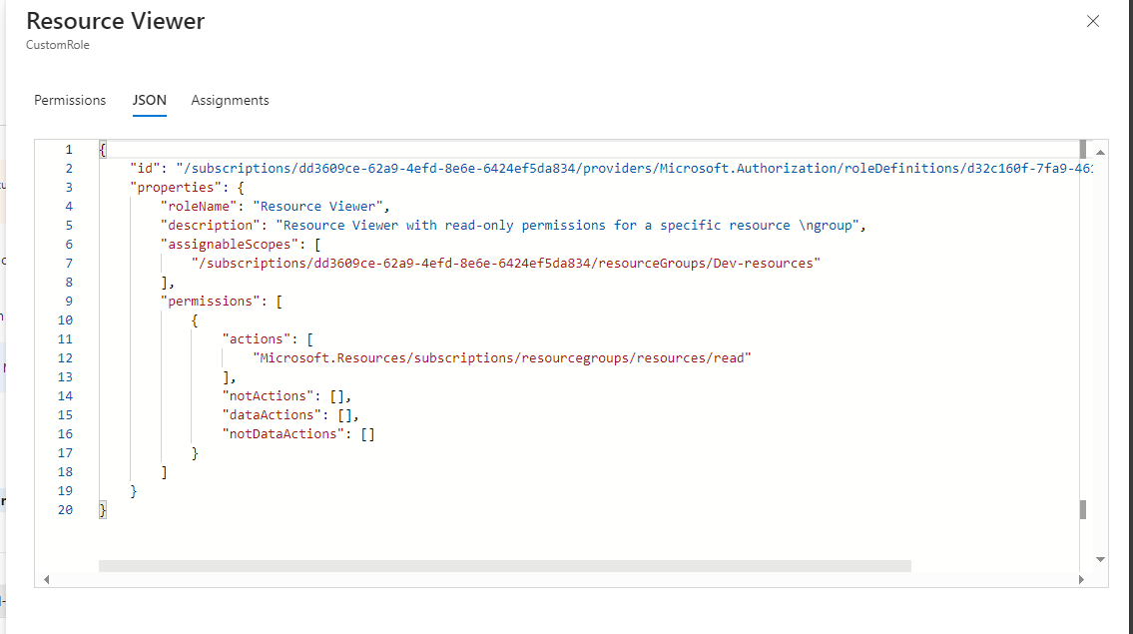

**2. Assign the Resource Viewer role to the Developers group created earlier.**

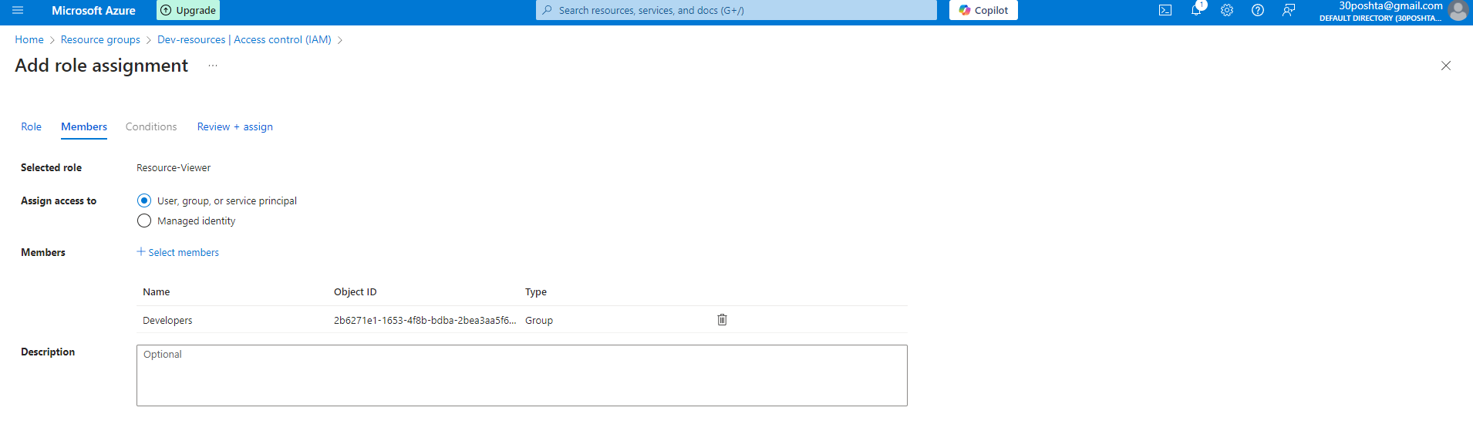

**3. Assign the built-in Contributor role to the Admins group for the same resource group.**

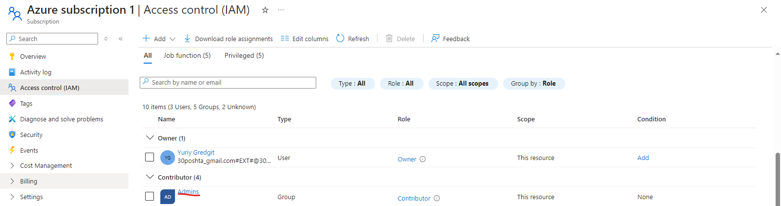

**4. Verify that members of the Developers group have only read access and members of the Admins group have full access to the resource group.**

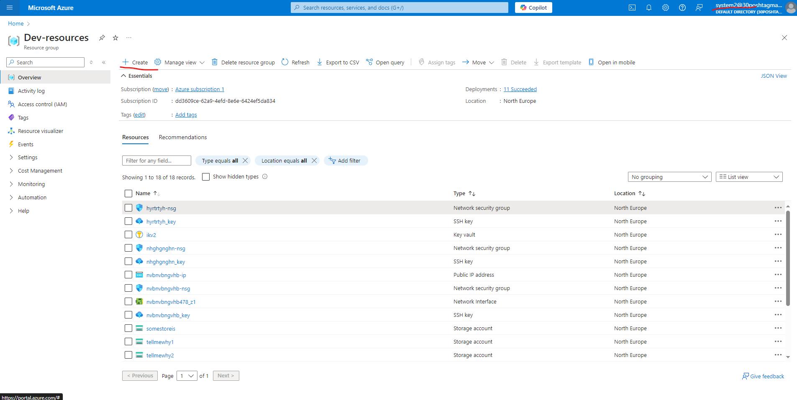

**Practical Task 4:** Securing Sensitive Information with Azure Key Vault Set up Azure Key Vault to securely store and manage sensitive information such as keys, secrets, and certificates. Requirements:

**1. Create a new Azure Key Vault in your subscription.**

**2. Add a secret to the Key Vault (e.g., a database connection string). –** secret added 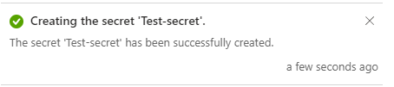

**3. Set access policies to grant the Application Developer role (assigned to the Developers group) permission to retrieve secrets from the Key Vault. –** Done this through IAM

**4. Verify that only members of the Developers group can access the stored secret. –** Verified that secret is accessible to dev user, not any other users

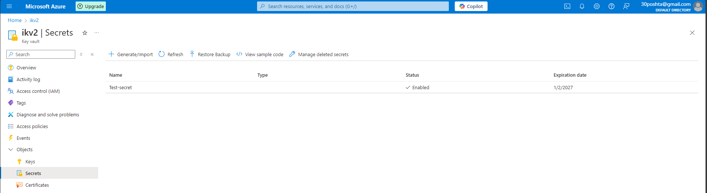 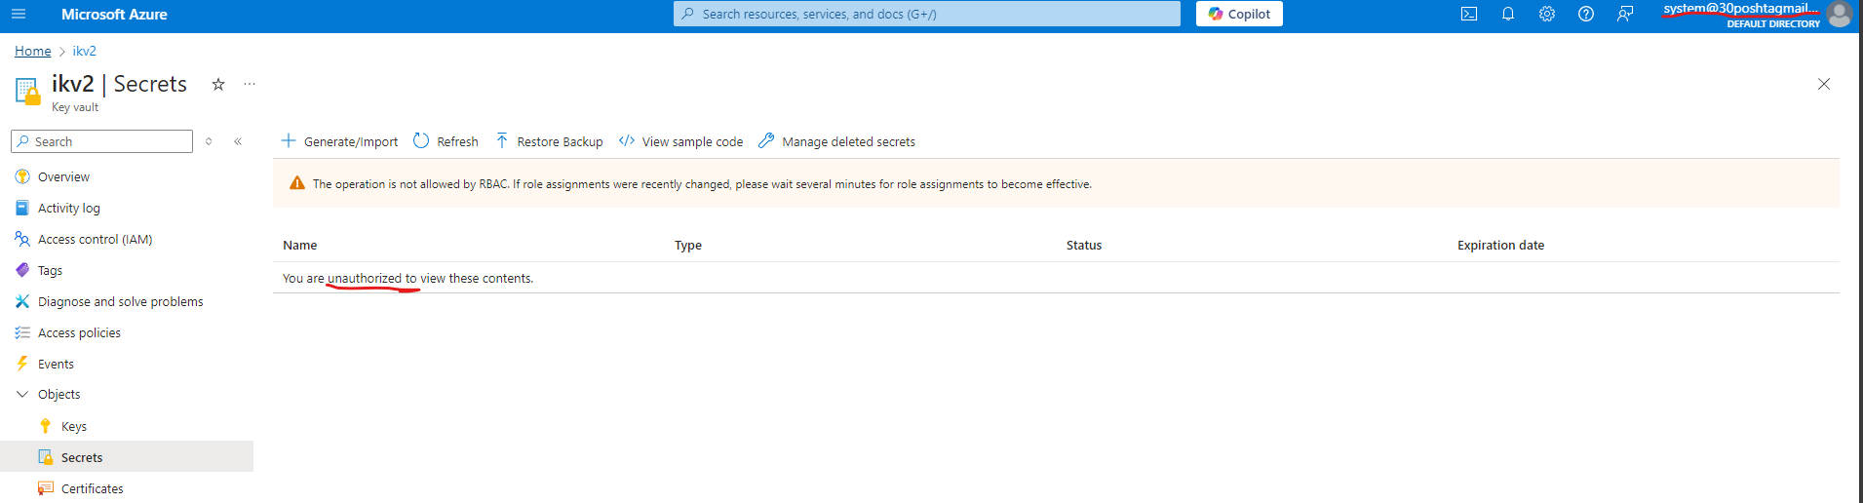

**Practical Task 5:** Creating and Assigning Basic Azure Policies Define and assign Azure Policies to enforce compliance with organizational standards for resource management. Requirements:

1. **Create an Azure Policy to enforce tagging for all newly created resources with a specific tag (e.g., Environment: Development). –** created respective policy

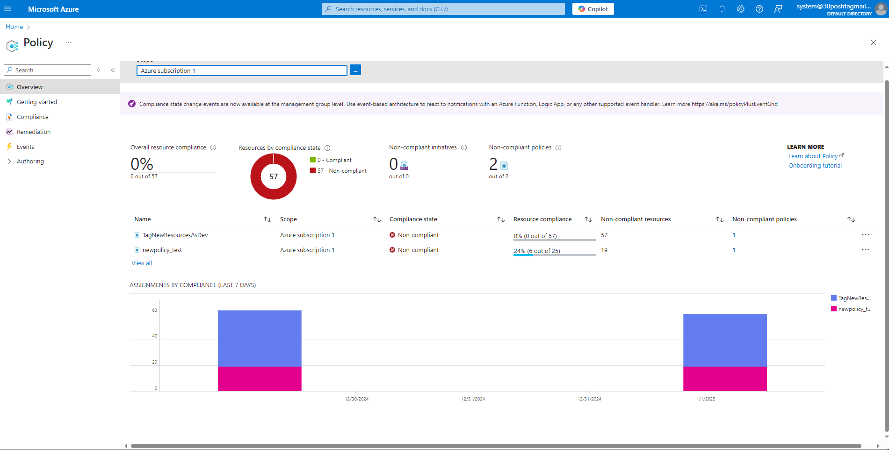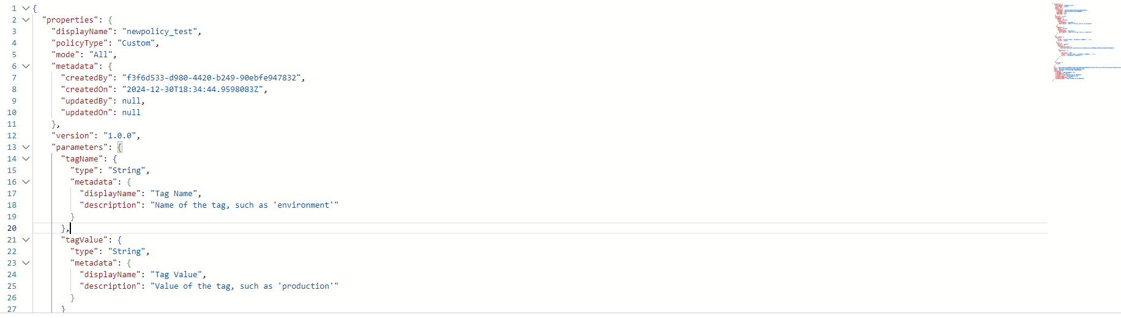

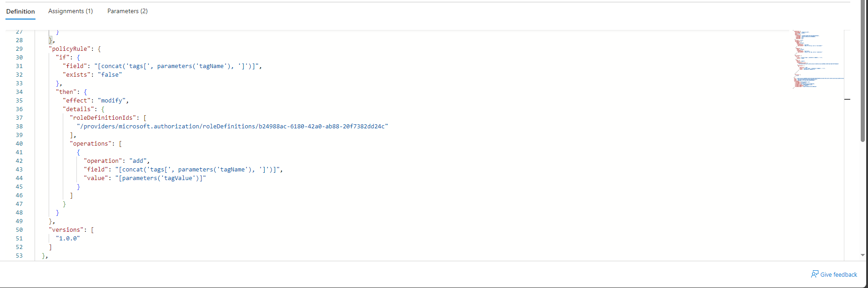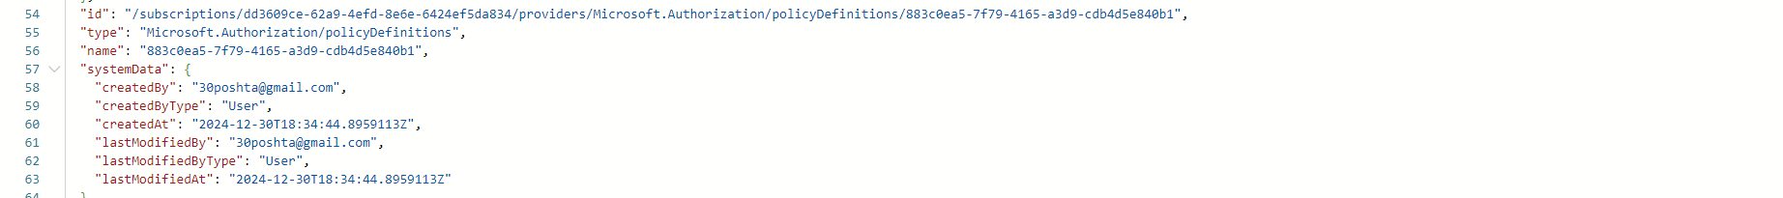

**2. Assign the policy to a resource group. –**

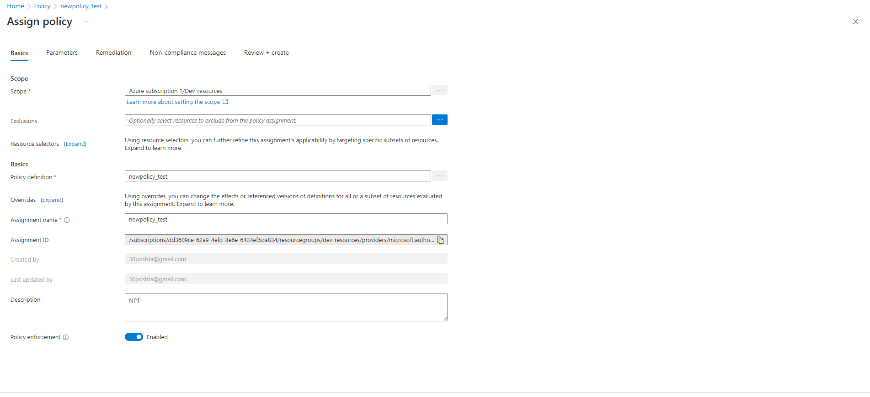

1. **Verify that any new resource created in the resource group without the required tag is marked as non-compliant. -** 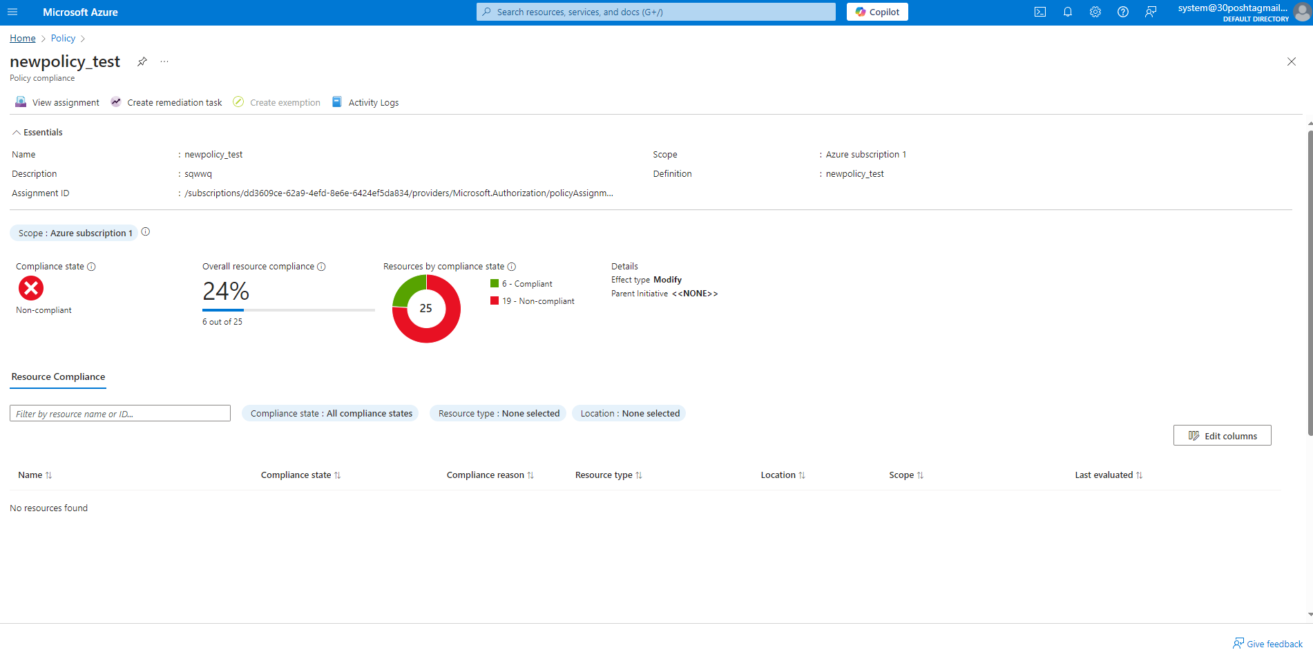

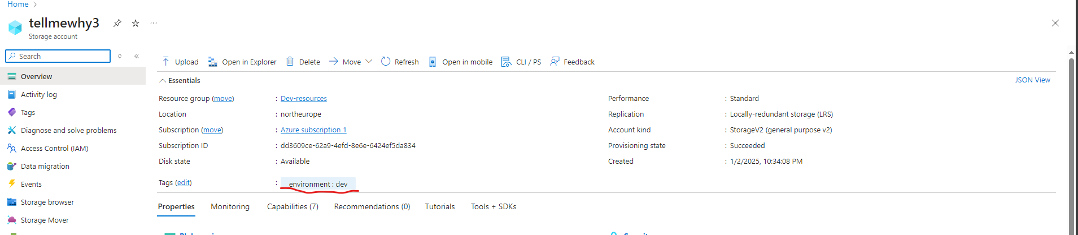



**4. Review and document the compliance status of the resource group. -** 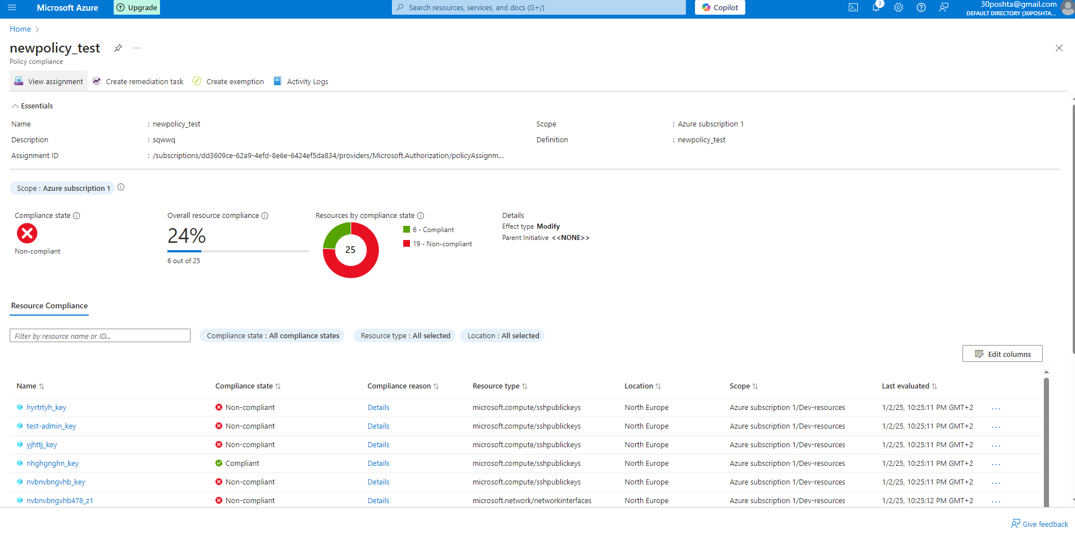

**Practical Task 6:** Using Policy Effects to Enforce Compliance Configure Azure Policies with different policy effects to enforce compliance and manage resources according to organizational standards. Requirements:

**1. Create a policy with the Audit effect to monitor and log untagged resources within a resource group.**

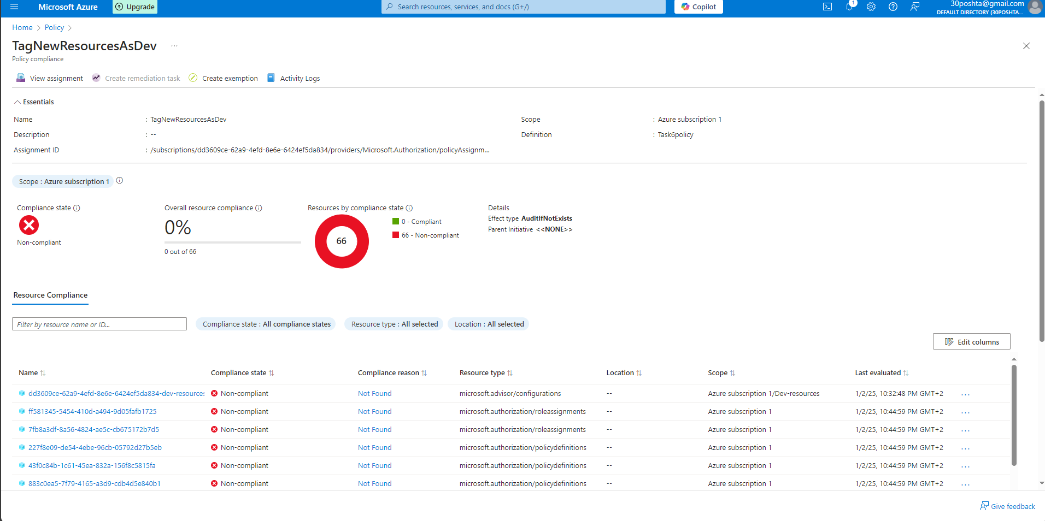

**2. Create a policy with the DeployIfNotExists effect to automatically add a specific tag (Owner: IT) to any newly created resource. –**

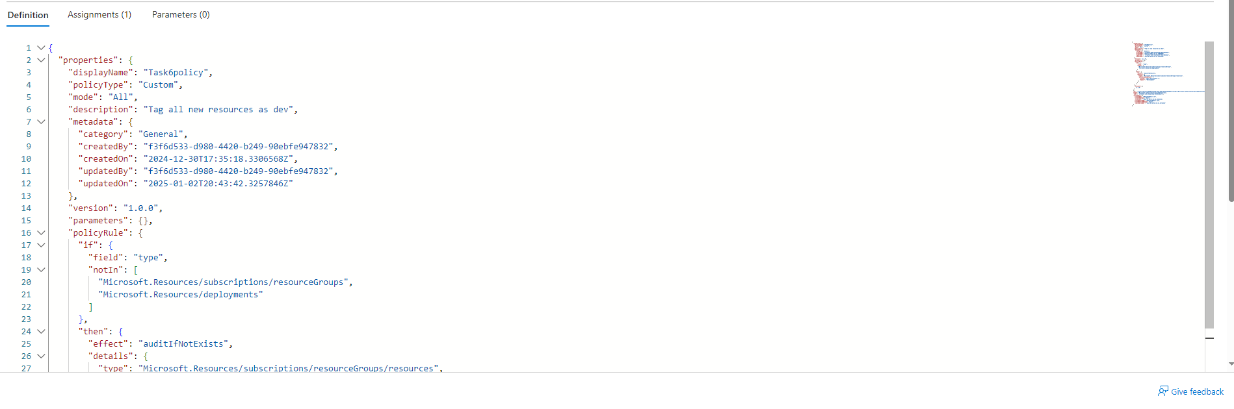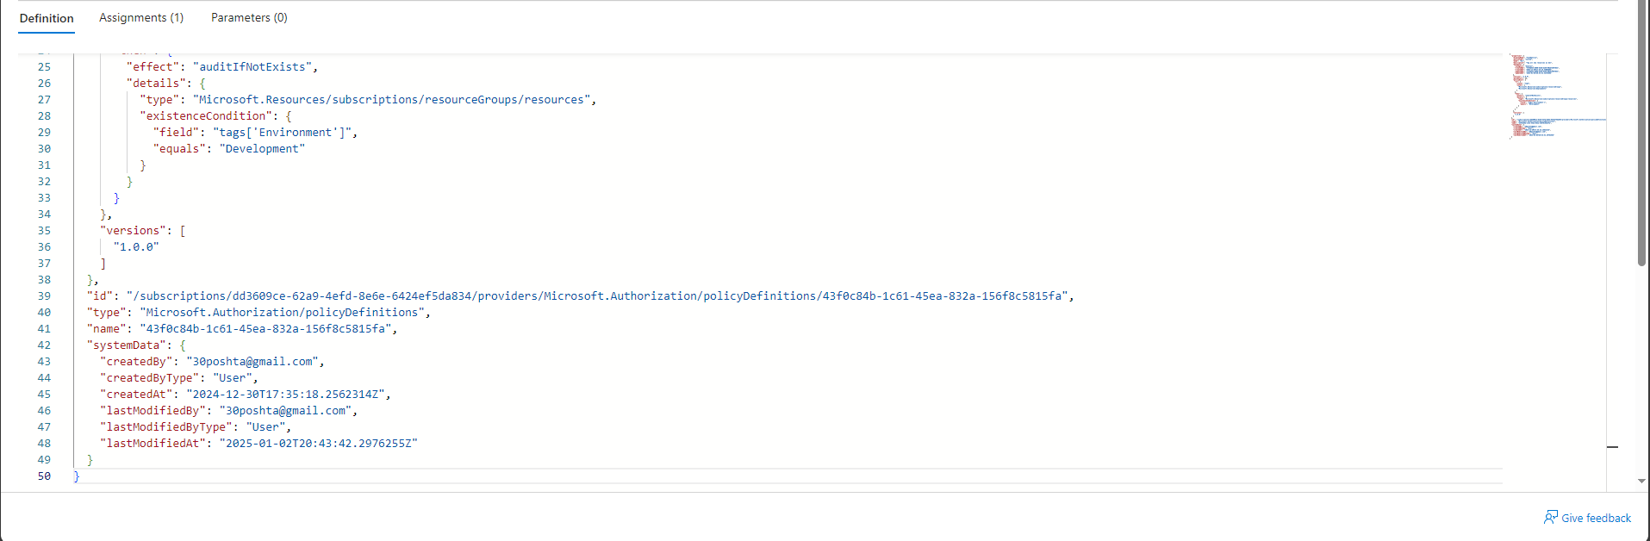

**3. Assign these policies to a resource group and verify their behavior by:**

**o Creating a resource without a tag and checking the compliance logs.** 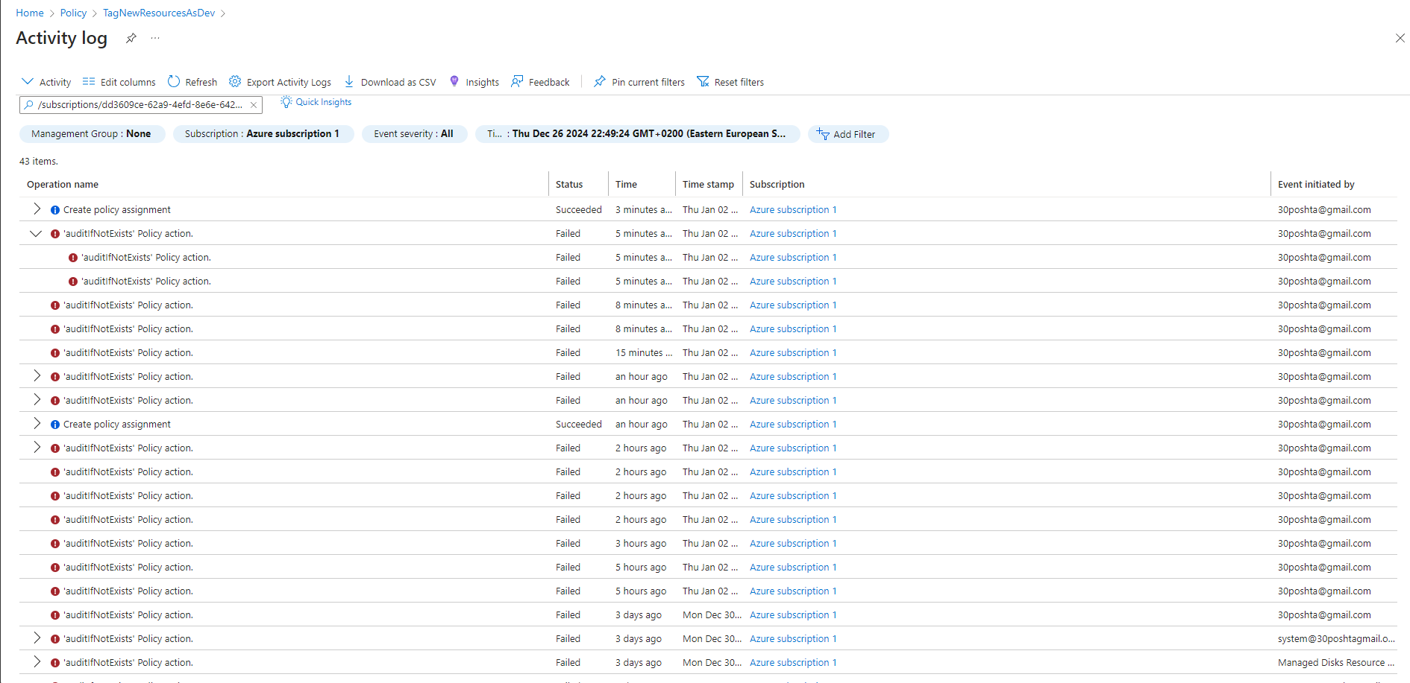

**o Creating a resource to validate the automatic tag deployment**



**Regarding task 6 – experienced a number of difficulties trying to complete task correctly. However, desired result is still unclear**